OA5. Comprensión lectora.
OA14. Expresión escrita.
LEER PRIMERO: Ésta guía es un poco diferente a las anteriores. En cierto modo, es una prueba para la casa. Se evaluará con nota de 2,0 a 7, por lo que el número de respuestas correctas e incorrectas afectará la calificación. EVITA COPIAR a toda costa; algunas de las actividades están diseñadas para que no pueda haber dos respuestas iguales. Es MUY RECOMENDABLE usar las guías anteriores como ayuda.
First name (nombre)______________________________
Last name (apellido) ______________________________
Date (fecha) _______________________________________

- [ENG] Read the text carefully and answer the following activities.
[ESP] Lee el texto cuidadosamente y responde las siguientes actividades.
Carolina is a Chilean girl. She lives in Castro, Chiloé. She lives with her family in an old house. She is eleven years old, and she has got an older sister, Emilia, and a younger brother, Juan.
She starts her day at about half past seven. She gets up, goes to the bathroom, takes a shower, brushes her teeth, and gets dressed. Then, she has breakfast and, at eight five, she turns on her computer to attend online classes.
Classes begin at a quarter past eight. After school, at a quarter past one, she disconnects from the internet, and has lunch (today, it is a salty dish: mashed potatoes and sausage!). After that, she does her school homework and, when she finishes it, she helps her mom set the table to have once.
At half past seven the family has once together (today it is savoury bread with sweet blackberry marmalade!). Carolina is a very helpful girl, so she helps her mother cleaning up everything after having once.
She usually watches TV for a while after having once and, at about ten o’clock the most, she brushes her teeth again, puts on her pajamas and goes to bed. Her mother always kisses her good night before she falls asleep. Carolina is a very happy girl!
¿SABÍAS QUÉ? La palabra once, usada para referirnos al momento en que la gente come por la tarde en Chile, no tiene equivalencia directa en inglés. Debido a esto, la hemos dejado en español y letra cursiva.

- [ENG] Answer the following questions about Carolina, in English. All the answers can be found in the text. Use a dictionary to locate words you do not know!
[ESP] Responde las siguientes preguntas sobre Carolina, en inglés. Todas las respuestas pueden ser encontradas en el libro. ¡Usa un diccionario para encontrar palabras que desconozcas!
- Where does Carolina live? Is it a new or an old house?
_________________________________________________________________________________.
- What’s her brother’s name? And her sister’s name?
_________________________________________________________________________________.
- What dish does she have for today? Is it salty or bitter?
__________________________________________________________________________________.
- What does she have today for once? What does it taste like?
___________________________________________________________________________________.
- [ENG] Use the clocks to indicate the time mentioned in the following sentences from the text.
[ESP] Usa los relojes para indicar la hora mencionada en las siguientes oraciones del texto.
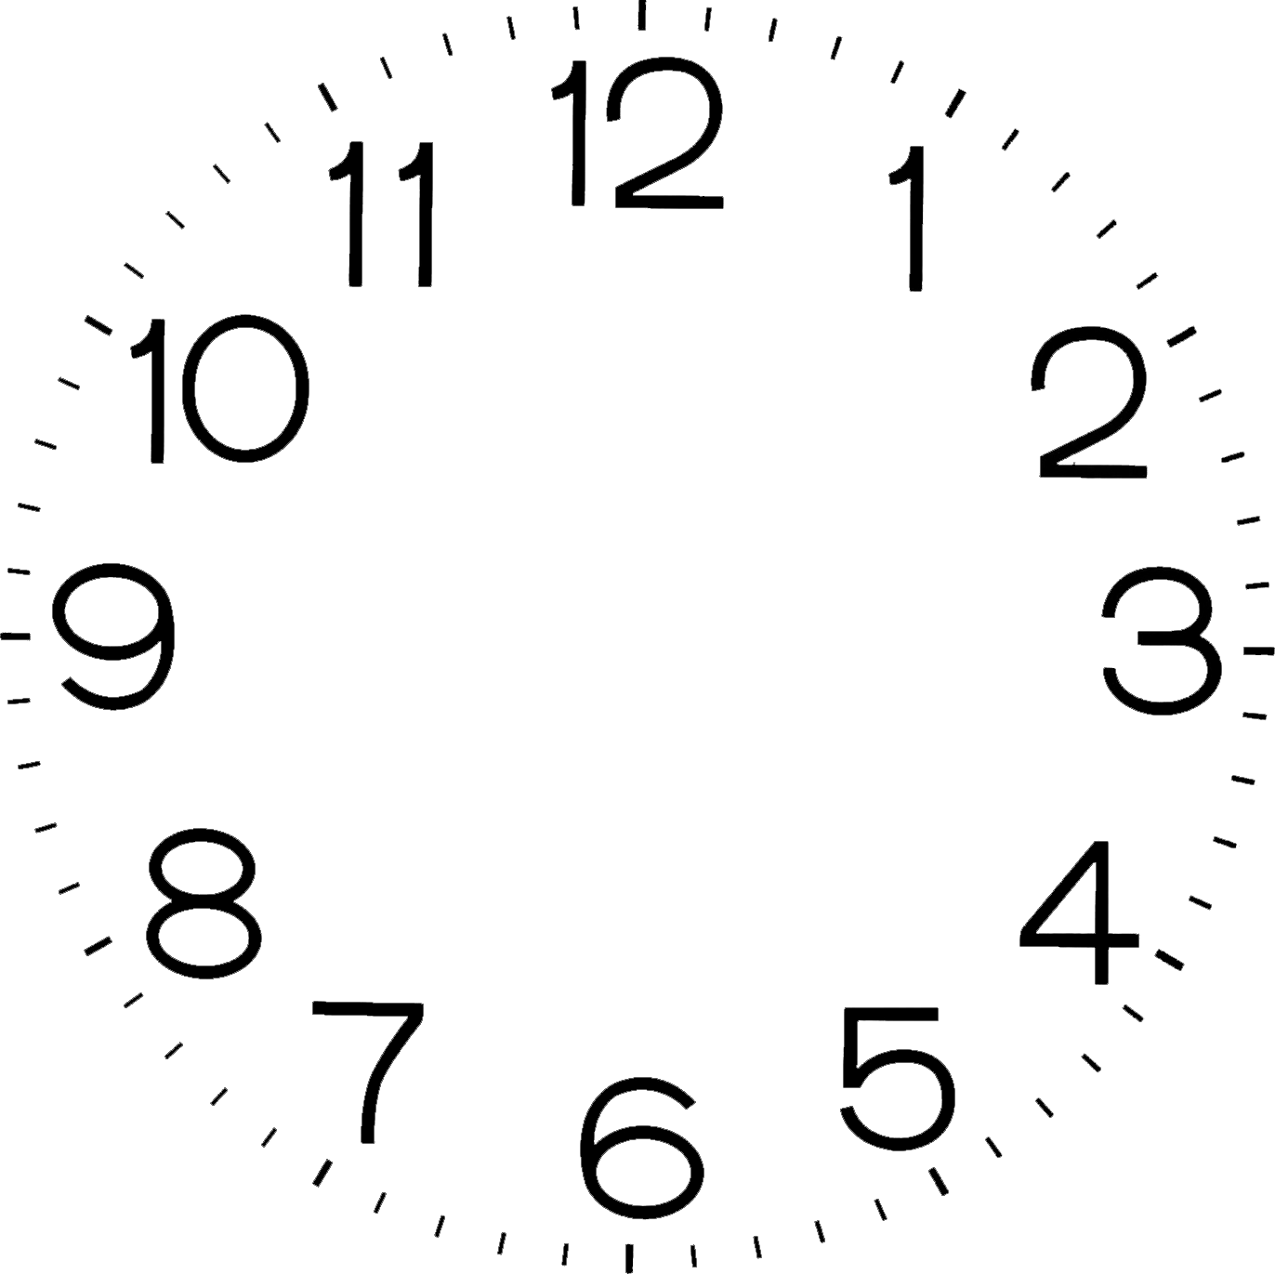
Then, she has breakfast and, at eight five, she turns on her computer to attend online classes. | After school, at a quarter past one, she disconnects from the internet, and has lunch. | at about ten o’clock the most, she brushes her teeth again, puts on her pajamas and goes to bed.

