OA9. Comprensión lectora.
OA14. Expresión escrita.
Mark:
First name (nombre)______________________________
Last name (apellido) ______________________________
Date (fecha) _______________________________________

LEER PRIMERO: Ésta guía es un poco diferente a las anteriores. En cierto modo, es una prueba para la casa. Se evaluará con nota de 2,0 a 7, por lo que el número de respuestas correctas e incorrectas afectará la calificación. EVITA COPIAR a toda costa; algunas de las actividades están diseñadas para que no pueda haber dos respuestas iguales. Es MUY RECOMENDABLE usar las guías anteriores como ayuda.

- [ENG] Read the article “The Athens of South America”, and answer the following activities.
[ESP] Lee el artículo “La Atenas de Sudamérica”, y responde las siguientes actividades.
I live in a huge and contemporary city in the centre of Colombia. The city is called Santa Fé de Bogotá and is located in the department of Cundinamarca. It is the capital city of Colombia which means that it is the largest and most populous city of my country. The city is surrounded by high mountains, rivers and amazing landscapes. The weather is frequently cold. It includes rainy, windy and cloudy days.
The city centre is the most expensive and noisiest place here. It is also the most dangerous one after midnight. People are always running and rushing for their jobs, school, and other duties. Traffic and public transportation are awful, too. TransMilenio is the main public transport, but most of the time it is unsafe, crowded, or really slow. For that reason, I prefer to take a taxi or drive my car.
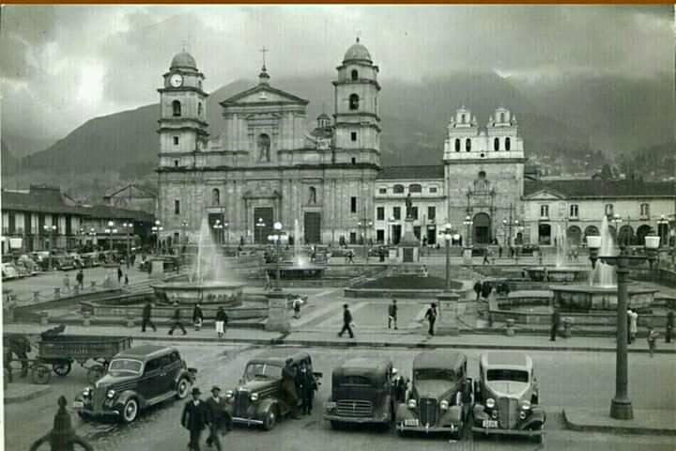
My city has got a variety of excellent universities as well, like the Universidad Nacional and Pontificia Universidad Javeriana, as well as some important libraries. For this reason, many people identify Bogotá as “The Athens of South America” for its growing education and culture.
In addition, Bogotá has 160 shopping malls. However, the most notable malls are Centro Andino, Santafé and Centro Mayor. Although, if you prefer quiet places, you can visit the historical area instead. There, you may find interesting places full of history and culture, such as La Casa de la Moneda, the elegant and big Colon Theater, the Monserrate sanctuary, or the old neighborhood of La Candelaria. You can take photographs, watch different plays or go for a walk. Also, you can eat typical food such as tamales or changua. If you prefer modern places, you can go and drink a cup of coffee at the modern Hard Rock Café in Atlantis Plaza mall.
Finally, I love my city a lot because there are so many places to visit and activities to do that you do not know where to start. I consider that it is the best place to live, and I would never move from here!

- [ENG] Read the texts again and then write down if the sentences below are TRUE (T) or FALSE (F). Correct the false ones.
[ESP] Lee los textos nuevamente y entonces escribe si las oraciones debajo son VERDADERAS (T) o FALSAS (F). Corrige las falsas.

- Bogotá is located in the department of Cundinamarca. __________
______________________________________________________________________
- The narrator has said that Bogotá’s city centre is the safest __________
place in the city.
_______________________________________________________________________

- Bogotá’s administration has built a safe, uncrowded and fast __________
public transportation system.
_________________________________________________________________________
- People have identified Bogotá as “The Athens of South America __________
because of its growing education and culture.
__________________________________________________________________________
- Construction workers have built around 200 shopping __________
malls in Bogotá.
__________________________________________________________________________

- [ENG] Create a description of a town or city you like using at least 150 words. Additional points may be granted for successfully using the Present Perfect tense when possible. The words in the box below may be of help!
[ESP] Crea una descripción de un pueblo o ciudad que te guste usando al menos 150 palabras. Puntaje adicional podrá ser otorgado al usar con éxito el Presente Perfecto cuando sea posible. ¡Las palabras en el recuadro debajo te pueden ser útiles!
Adjectives | Modern, new, huge, beautiful, elegant, tall, big, quiet, fancy, rich, dangerous, fantastic
Opposites | Old, tiny, ugly, short, small, noisy, plain, poor, safe, terrible, horrible, awful
Places | Mall – restaurant - bank - public / private school – factory-station-shop-café - church – hospital –university store- library-gym– building – park – bank – house – square – swimming pool - club – salon – drugstore / chemist’s – hotel – traffic light – disco/bar- playground – flower shop – supermarket / grocery store- movie theater – zoo- airport- football stadium
Location | In front of, between, behind, next to, over, beyond, under, on the right/left, at the top/bottom
Other words | Uncountable: Crime, danger, pollution, traffic  Countable: Robbery, politicians, people, buses, cars
________________________________________________________________________________________________________________________________________________________________________________________________________________________________________________________________________________________________________________________________________________________________________________________________________________________________________________________________________________________________________________________________________________________________________________________________________________________________________________________________________________________________________________________________________________________________________________________________________________________________________________________________________________________________________________________________________________________________________________________________________________________________________________________________________________________________________________________________________________________________________________________________________________________________________________________________________________________________________________________________________________________________________________________________________________________________________________________________________________________________________________________________________________________________________________________________________________________________________________________________________________________________________________________________________________________________________________________________________________________________________________________________________________________________________________________________________________________________________________________________________________________________________________________________________________________________________________________________________________________________________________________________________________________________________________________________________________________________________________________________________________________________________________________________________________________________________________________________________________________________________________________________________________________________________________________________________________________________________________________________________________________________________________________________________________________________________________________________________________________________________________________________________________________________________________________________________________________________________________________________________________________________________________________________________________________________________________________________________________________________________________________________________________________________________________________________________________________________

