OA9. Comprensión lectora.
OA14. Expresión escrita.
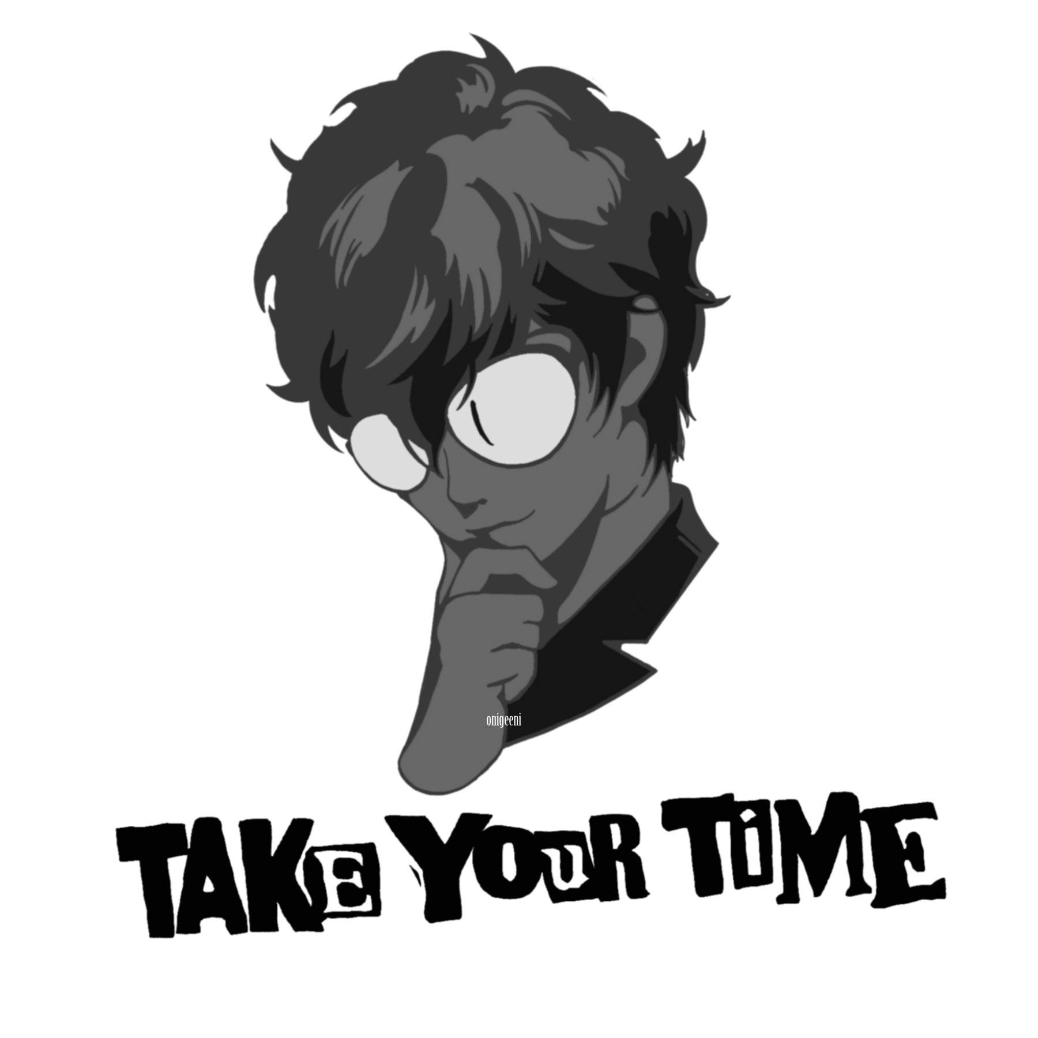
First name (nombre)______________________________
Last name (apellido) ______________________________
Date (fecha) _______________________________________

LEER PRIMERO: Ésta guía es un poco diferente a las anteriores. En cierto modo, es una prueba para la casa. Se evaluará con nota de 2,0 a 7, por lo que el número de respuestas correctas e incorrectas afectará la calificación. EVITA COPIAR a toda costa; algunas de las actividades están diseñadas para que no pueda haber dos respuestas iguales. Es MUY RECOMENDABLE usar las guías anteriores como ayuda.

- [ENG] Read the text below answer the questions in the following activities.
[ESP] Lee el texto debajo y responda las preguntas en las siguientes actividades.
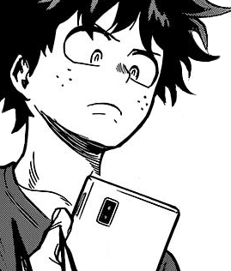
The digital landscape has put increased pressure on teenagers today, and we feel it. There are so many social media channels: Facebook, Twitter, Instagram, Snapchat, Tumblr, you name it. I made a conscious decision to avoid Snapchat and Instagram because of the social pressure I saw them putting on my 14-year-old little sister. If my mum turned off the WiFi at 11pm, my sister would beg me to turn my phone into a hotspot. She always needed to load her Snapchat stories one more time, or to reply to a message that had come in two minutes ago because she didn’t want her friend to feel ignored. If I refused, saying she could respond in the morning, I’d get the “You’re ruining my social life” speech. Even as a teenager as well, I sometimes find this craze a little baffling.

A new study has found that teenagers who engage with social media during the night could be damaging their sleep and increasing their risk of anxiety and depression. Teenagers spoke about the pressure they felt to make themselves available 24/7 and the resulting anxiety if they did not respond immediately to texts or posts. Teens are so emotionally invested in social media that a fifth of secondary school pupils will wake up at night and log on just to make sure they don’t miss out. Perhaps the worst thing about this is that teenagers need more sleep than adults do, so night-time social media use could be detrimental to their health. A lack of sleep can make teenagers tired, irritable, and depressed.

During the summer holidays, I lost my phone. And for the week that I was phoneless, it felt like a disaster. I love my phone. It gives me quick access to information and allows me to be constantly looped in with my friends, to know exactly what is going on in their lives. So, when I didn’t have my phone for a week, I felt a slight sense of FOMO, or if you’re not up to speed with the lingo, fear of missing out. By the end of the week, I’d got used to not having a phone and I’d quite enjoyed the break from social media. But there was still a lingering sense of sadness at the back of my mind that there would be conversations I had missed, messages that had been sent, funny videos shared and night-time chats that I would probably never get to see.
By June Eric Udorie
in http://www.theguardian.com/commentisfree/2015/sep/16/social-media-mental-health-teenagers-government-pshe-lessons

- [ENG] Read the previous text again and answer the questions below.
[ESP] Lee el texto anterior nuevamente y responde las preguntas debajo.

- Name four things teenagers usually use social media for.
_______________________________________________________________________________________
_______________________________________________________________________________________

- What are some of the effects of night-time social media use on teenagers?
_______________________________________________________________________________________
_______________________________________________________________________________________
_______________________________________________________________________________________

- What is the ‘fear of missing out’, also known as FOMO?
_______________________________________________________________________________________
_______________________________________________________________________________________

- What do you think about the author’s view on social media? Is it positive or negative? Do you agree or disagree with her? Answer these questions in 50-100 words.

_______________________________________________________________________________________
_______________________________________________________________________________________
_______________________________________________________________________________________
_______________________________________________________________________________________
_______________________________________________________________________________________
_______________________________________________________________________________________

- [ENG] Read the text again and then write down if the sentences below are TRUE (T) or FALSE (F). Correct the false ones.
[ESP] Lee los textos nuevamente y entonces escribe si las oraciones debajo son VERDADERAS (T) o FALSAS (F). Corrige las falsas.

- The author doesn’t understand her sister’s obsession with social
media at times. ________
__________________________________________________________________.
- Teenagers never feel pressured to be constantly online. _______
_____________________________________________________________.

- The author simply hated it when she was unable to log on for a week. ________
__________________________________________________________________.

