OA3. Conocimiento del Inglés para comprender y producir.
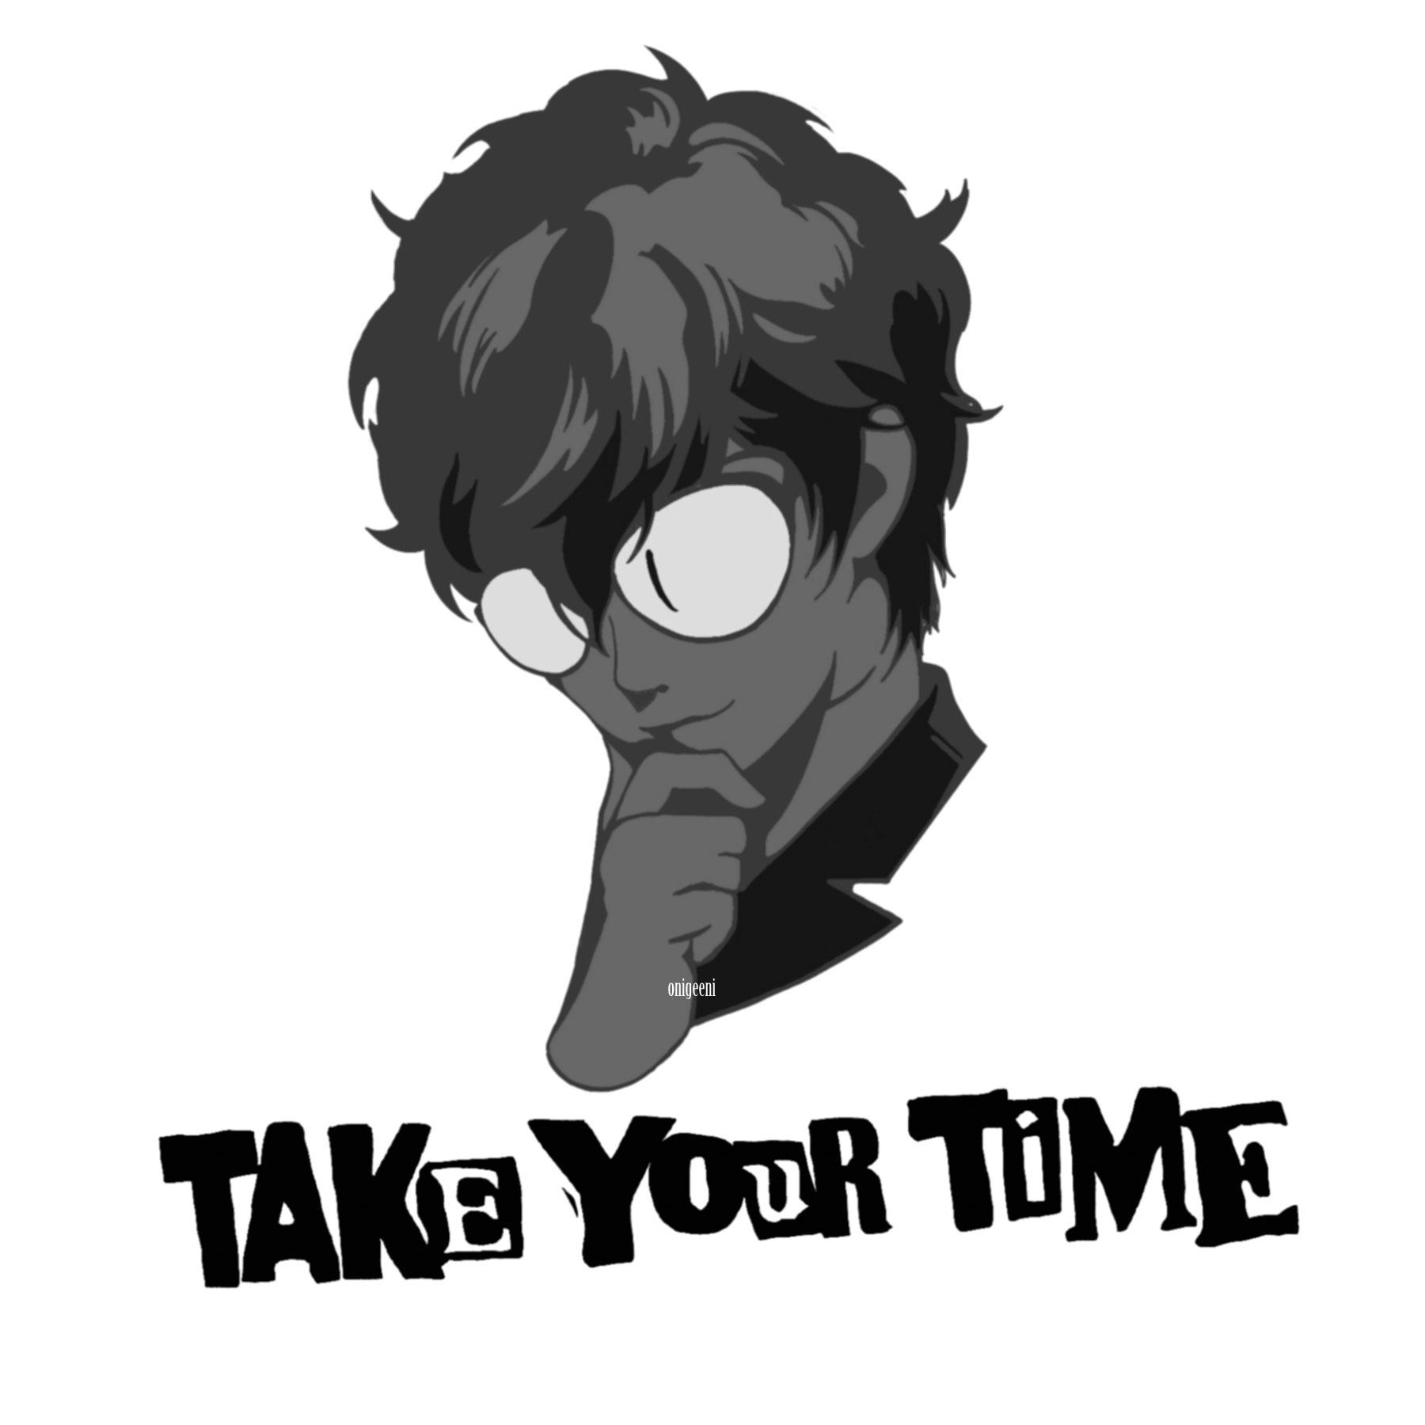
Mark:
First name (nombre)______________________________
Last name (apellido) ______________________________
Date (fecha) _______________________________________

LEER PRIMERO: Ésta guía es un poco diferente a las anteriores. En cierto modo, es una prueba para la casa. Se evaluará con nota de 2,0 a 7, por lo que el número de respuestas correctas e incorrectas afectará la calificación. EVITA COPIAR a toda costa; algunas de las actividades están diseñadas para que no pueda haber dos respuestas iguales. Es MUY RECOMENDABLE usar las guías anteriores como ayuda.

- [ENG] Read the text carefully and do the next activities.
[ESP] Lee el texto cuidadosamente y haz las siguientes actividades.
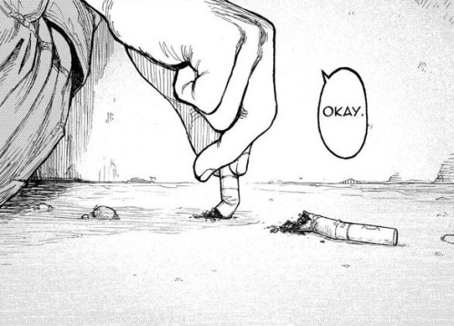
Smoking kills 6 million people every year around the world, and more than half a million non-smokers get affected from second hand smoke. According to the World Health Organization (WHO), tobacco use is the leading cause of preventable death. In fact, tobacco kills more people every year that alcohol, AIDS, car accidents, illegal drugs, murders and suicides combined. Unless more people quit smoking, this deadly habit could kill up to one billion people in the 21st century. The World No Tobacco Day (WNTD) is observed worldwide every year on May 31st to help smokers abstain from consuming tobacco for at least 24 hours, smokers are also encouraged to give up the habit for life.
WNTD was started in 1987, when the World Health Assembly (WHA) of the WHO passed a resolution which formed the initiative. The primary aim of WNTD is to educate people about the deadly nature of tobacco. Each year on this day WHO chooses a theme that carries a message to quit smoking and raise awareness on the dangers of smoking. This year the WHO has taken a new direction that stresses the legal side of tobacco prevention, as opposed to the typical "awareness" theme.
WHO is persuading more countries to sign a global treaty to ensure public protection from smoking. The treaty, 'The WHO Framework Convention on Tobacco Control' (FCTC) is known as the world's primary tobacco stopping instrument, and is the focus for the theme this year. The treaty was drafted 6 years ago and 172 countries have signed it, though 20 percent have done nothing to implement it's recommendations. In addition, major countries such as the U.S. and Indonesia have not even signed it. In the U.S. tobacco abuse is responsible for 440,000 deaths annually. Eighty percent of adult smokers begin smoking before age 18. Adolescents who smoke are more likely to drink heavily and more likely to use illicit drugs than their nonsmoking counterparts. In addition, adolescents who smoke are more likely to have panic disorders and other anxiety disorders.
The WNTD campaign will focus on fully implementing the treaty to protect present and future generations from the consequences of tobacco consumption and exposure.

- [ENG] Read the text again and then write down if the sentences below are TRUE (T) or FALSE (F). Correct the false ones, providing evidence from the text.
[ESP] Lee los textos nuevamente y entonces escribe si las oraciones debajo son VERDADERAS (T) o FALSAS (F). Corrige las falsas, entregando evidencia del texto.

- Tobacco harms only smokers. __________
___________________________________________________________________________
___________________________________________________________________________

- The World Health Assembly aims at making people aware that __________
cigarettes cause death.
___________________________________________________________________________
___________________________________________________________________________

- Countries all over the world have signed the FCTC. __________
___________________________________________________________________________
___________________________________________________________________________

- [ENG] Rewrite the underlined sentence in the text using the appropriate conditional: Conditional Zero, First Conditional, Second Conditional or Third Conditional.
[ESP] Reescribe la oración subrayada en el texto usando el condicional apropiado: Condicional Cero, Primer Condicional, Segundo Condicional o Tercer Condicional.
___________________________________________________________________________________________
___________________________________________________________________________________________

- [ENG] Answer the following question in a paragraph with at least 180 words: What strategies could you suggest for smokers to help them stop smoking? *Bonus points for using some comparatives and superlatives.
[ESP] Responde a la siguiente pregunta en un párrafo con al menos 180 palabras: ¿Qué estrategias podrías sugerir para ayudara que los fumadores dejen de fumar? *Puntos extra por usar algunos comparativos y superlativos.

______________________________________________________________________________________________________________________________________________________________________________________
______________________________________________________________________________________________________________________________________________________________________________________
______________________________________________________________________________________________________________________________________________________________________________________
______________________________________________________________________________________________________________________________________________________________________________________
______________________________________________________________________________________________________________________________________________________________________________________
______________________________________________________________________________________________________________________________________________________________________________________
______________________________________________________________________________________________________________________________________________________________________________________
______________________________________________________________________________________________________________________________________________________________________________________
______________________________________________________________________________________________________________________________________________________________________________________

