OA9. Comprensión Lectora: Demostrar comprensión de ideas generales e información explícita en textos adaptados y auténticos simples, en formato impreso o digital, acerca de temas variados (como experiencias personales, temas de otras asignaturas, del contexto inmediato, de actualidad e interés global o de otras culturas) y contienen las funciones del año.
First name (nombre)______________________________
Last name (apellido) ______________________________
Date (fecha) _______________________________________

What do you like? - Likes and dislikes

[ENG] Read the next expressions used when we want to talk about what we like or don’t like in English.
[ESP] Lee las siguientes expresiones usadas cuando queremos hablar acerca de lo que nos gusta o no nos gusta en Inglés.

- [ENG] Put an X on the free time activity or thing you love, like, kind of like, don’t like, hate or have never tried. Use the examples on the next page.
[ESP] Pon una X en el pasatiempo o cosa que tú ames, guste, más o menos guste, no te guste, odies o nunca hayas intentado. Usa los ejemplos en la siguiente página.

Free time activities | Love | Like | Kind of like | Don’t like | Hate | Have never tried
Watching TV & Films
Swimming
Singing
Studying
Reading
Walking
Jogging
Listening to music
Shopping
Drawing
Travelling
Chatting with your friends
Playing videogames
Cooking
Eating
Riding a bike
Doing exercise

Positive Negative
Yes, I love… (100%) No, I don’t really like/ I really dislike … (40%)
Yes, I really like… (90%) No, I don’t like/dislike … very much (30%)
Yes, I like… (75%) No, I don’t like/dislike … (10%)
Yes, I kind of like… (60%) No, I hate … (0%)

[ENG] Examples of questions and responses to ask someone about their likes and dislikes:
[ESP] Ejemplos de preguntas y respuestas para preguntarle a alguien sobre lo que le gusta y lo que no le gusta:
Do you …. (_______)? Yes, I … / No, I….
-Do you like boxing? No, I have never tried.
-Do you hate reading? No, I don’t. I like it.
- Do you like travelling? Yes, I really like it. I travel a lot!

- [ENG] Complete the conversation with the correct form of the words in brackets.
[ESP] Completa la conversación con la forma correcta de las palabras en paréntesis.

SARA: Hi you two! What are you doing?
STEVE: We’re playing basketball. Do you want to play?
SARA: No thanks. I (1) ________________________ (not like / play) basketball.
CARL: Wow! I (2) ________________________ (love / play) basketball, it’s great!
STEVE: What do you (3) ________________________ (like / do)?
SARA: Well, I (4) ________________________ (like / ride).
CARL: Yeah! That can be fun.
SARA: And I (5) ________________________ (like / dance).
STEVE: Dancing! Oh, I (6) ________________________ (hate / dance). I can’t dance.
SARA: That’s not true. Everyone can dance.
STEVE: Not me!
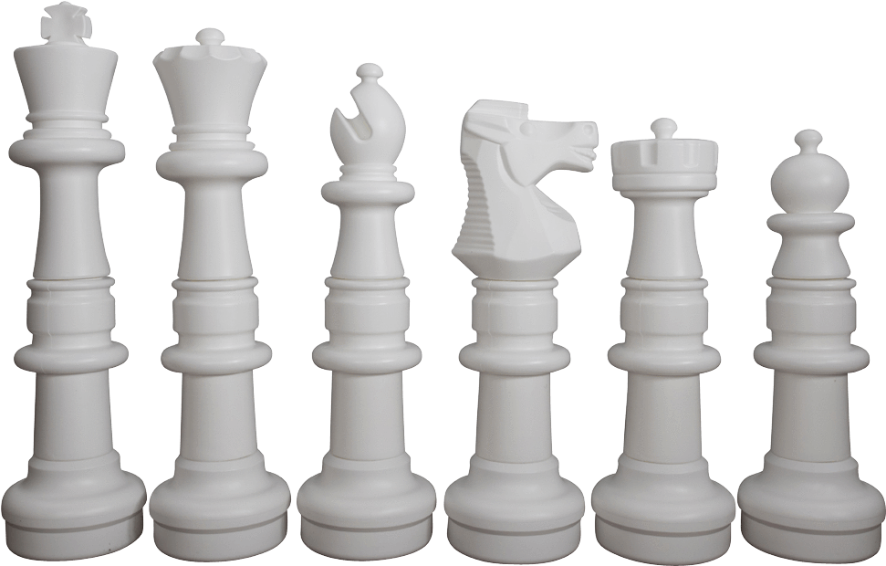
SARA: So I know you (7) ________________________ (like / play) basketball, but what else do you (8) ________________________ (like / do)?
STEVE I: (9) ________________________ (like / play) chess.
CARL: Chess! That’s boring.

