|  |
| --- |
| **OA9. Comprensión lectora:** Demostrar comprensión de ideas generales e información explícita en textos adaptados y auténticos simples, en formato impreso o digital, acerca de temas variados […] y que contienen las funciones del año. |



**How globalisation through cities heats up cultural aggression**

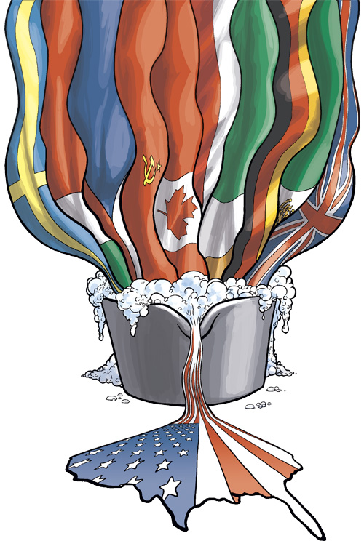

**Multiculturalism and Globalisation**

**Stirring the Melting Pot:**

First name (nombre)______________________________  
Last name (apellido) ______________________________  
Date (fecha) _______________________________________

1. **[ENG] Reading Comprehension:** Read the text below and decide which answer (A, B, C, or D) best fits each gap. Circle the right option.  
   **[ESP] Comprensión Lectora:** Lee el texto debajo y decide cuál respuesta llena mejor el espacio. Encierra en un círculo la alternativa correcta.

By 2050, [70% of the world’s 9 billion people](http://www.unhabitat.org/content.asp?cid=6040&catid=7&typeid=5) **…1** in cities. Globalisation is creating a series of melting pots around the world. These are places where ancient cultures can build **…2** each other or collide. New York, London, Sydney and Melbourne: these are places of liberty and ‘free speech’. But these are also places of **…3** cultural tension.

This kind of tension is demonstrated in many forms. Aggressive comments whispered or [filmed on the train](http://www.youtube.com/watch?v=z4wWqfRzp_M). Astronomical [suicide rates among teens](http://www.npr.org/templates/story/story.php?storyId=98782569). The phrase ‘I’m not racist, but…’ and [‘shock jocks’ spreading cultural](http://www.abc.net.au/news/2012-12-13/jones-to-apologise-after-calling-lebanese-muslims-vermin/4426692) ignorance through the airwaves.

People direct **…4**towards that foreigner who prays to an unknown god or ‘stole’ an Aussie job to make the **…5** clothes they buy. But are these people in the vocal minority, or outspoken representatives of the majority?

Globalisation unites diverse cultures under one shared flag, encourages once oppressed groups to **…6** and blurs the borders between micro-communities. This makes it is easy for underlying prejudice to simmer and erupt. When a ‘minority’ group causes the melting pot to spill over, the city’s western middle-class, news media spins a story **…7** for the highest ratings, exacerbating this **…8**.

<http://vibewire.org/2013/06/>

|  |  |  |  |  |
| --- | --- | --- | --- | --- |
|  | a. are going to live | b. will live | c. are living | d. live |
|  | a. beside | b. besides | c. each side | d. on the side |
|  | a. heating | b. heat | c. heated | d. heater |
|  | a. hates | b. hatred | c. hated | d. hating |
|  | a. priceless | b. pricing | c. under-priced | d. overpriced |
|  | a. speak up | b. speak out | c. speak for | d. speak with |
|  | a. hidden | b. unplanned | c. unsuitable | d. tailored |
|  | a. pride | b. animosity | c. prejudice | d. privilege |

1. **[ENG] Reading Comprehension:** You are going to read a text about globalisation and multiculturalism.Use the words in the box below in their appropriate form to fill each gap.  
   **[ESP] Comprensión Lectora:** Leerás un texto sobre globalización y multiculturalismo. Usa las palabras en la caja debajo en la forma que corresponda para llenar cada espacio.

emerge – plural – colonies – work – perceive – fair – citizen – secure – vary – dominate

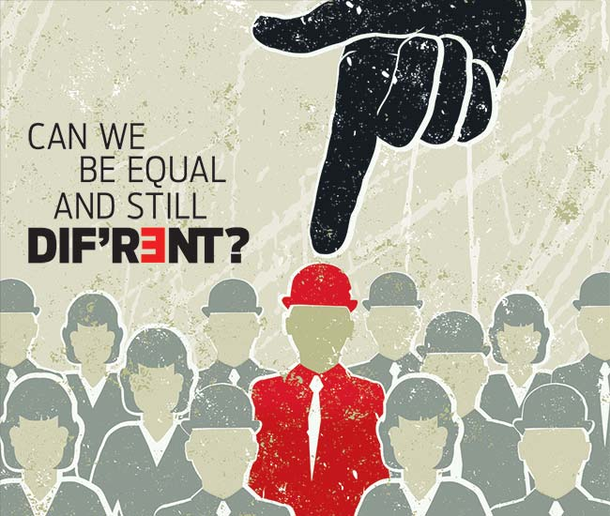

**and Emerging Models of Multiculturalism**

**Trends of Globalisation**

A viable alternative model of multiculturalism is seemingly **(9)______________** in the United Kingdom. Here, multiculturalism allowed spaces for the assertionof cultural rights of minorities to such an extent that the cultural rights of the Western civilisation are compromised.

Recently, Dr Rowan Williams, the Archbishop of Canterbury, proposed that the U. K. incorporate the Sharia in its legal system so that the Muslims in that country do not have to choose between their cultural right and their right as citizens. This model is similar to the (**10)________________** legal model that India inherits from its **(11)___________** past. This model may be **(12)____________** as in India but generates considerable cultural tensions as it arouses patriotic fervour of the cultures that have been ‘othered’ in the process (that is, from the **(13)__________________** of the members of such cultures, treated in an **(14) _______________** manner) besides providing grist to their mills of cultural phobias. A right wing cultural ‘backlash’ from the ‘othered’ cultures would result in sharpening cultural identities and transforming them into assertionsof self- determination that may undermine our accepted notions of nation state and **(15) _________________**. Such a model of multiculturalism proves to be counterproductive because it only aggravates cultural tensions and **(16)__________** .

The French have adopted a **(17)____________** of British multiculturalism. The state is strictly defined as a space that is neutral to all religions, including Roman Catholicism that is **(18)_________** in France.

<http://e08.cgpublisher.com/proposals/80/index_html> (adapted and abridged)