OA3 (Conocimiento del inglés para comprender y producir). Utilizar su conocimiento del inglés en la comprensión y producción de textos orales y escritos breves y claros, con el fin de construir una postura personal crítica en contextos relacionados con sus intereses e inquietudes.

Reflexive Pronouns: Examples
I found myself in trouble.
You enjoyed yourself at the party.
She helped herself to some food.
He cleaned the room by himself.
It destroyed itself with an explosion.
We gave ourselves a break.
Please, make yourselves at home.
They had to save themselves from disaster.

Subject Pronoun | Reflexive Pronoun | Object Pronoun
I | Myself | Me
You (singular) | Yourself | You
She | Herself | Her
He | Himself | Him
It | Itself | It
We | Ourselves | Us
You (Plural) | Yourselves | You
They | Themselves | Them

Activities:
I. READING COMPREHENSION: Read the story and choose the correct alternatives.
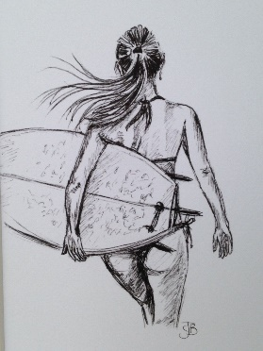
Our Vacation
Every year we go to Florida. We like to go to the beach.
My favorite beach is called Emerson Beach. It is very long, with soft sand and palm trees. It is very beautiful. I like to make sandcastles and watch the sailboats go by. Sometimes there are dolphins and whales in the water!
Every morning we look for shells in the sand. I found fifteen big shells last year. I put them in a special place in my room. This year I want to learn to surf. It is hard to surf, but so much fun! My sister is a good surfer. She says that she can teach me. I hope I can do it!

1.- What is the narrator’s favorite beach?  - Surf Beach  - Palm Beach  - Emerson Beach  - Long Beach  2.- What animals does the narrator see in the water?  - Dolphins and Whales  - Dogs and Cats  - Starfish and Sponges  - Sharks and Octopi  3.- How many shells did the narrator find last year?  - Five  - Fifty  - Fifteen  - Twelve | 4.- What does the narrator want to learn this year?  - Swimming  - How to find shells  - Sailing  - Surfing  5.- Where did the narrator put their shells last year?  - In Florida  - In a box  - In the garage  - In their room

Glossary: sand: arena / palm trees: palmeras / sandcastles: castillos de arena / sailboats: veleros / whales: ballenas / shells: conchas

II. REFLEXIVE PRONOUNS: Complete with the correct Reflexive Pronouns.
- Everyone! Welcome to my new home. Please, make __________________ at home.
- Joseph hurt __________________ after falling off a plane.
- Marie Curie won the Nobel Prize all by ______________________.
- Neil Armstrong and Buzz Aldrin stepped on the moon by ______________________.
- Is Clara enjoying the party? Tell her to help _____________________ to the food.
- I gave ___________________ a gift for getting a good mark on the test.
- We enjoyed ____________________ during the summer.
- Nobody is home. Jack is by ____________________.
- The Rodriguez locked _____________________ out of their house.
- The children promised ______________________ to be good.

